Vernacular Names: Fagot | Scientific Name: Neisosperma (Ochrosia) oppositifolia (Lam.) Fosberg & Sachet
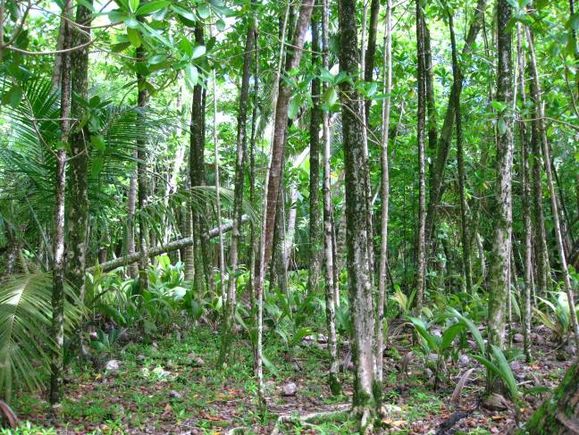  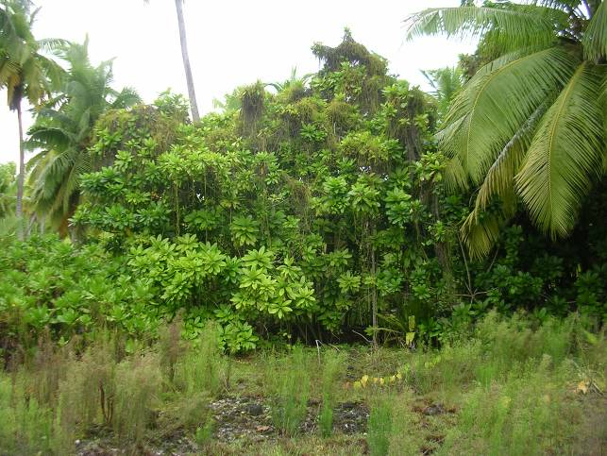 | 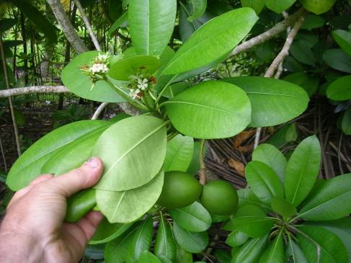  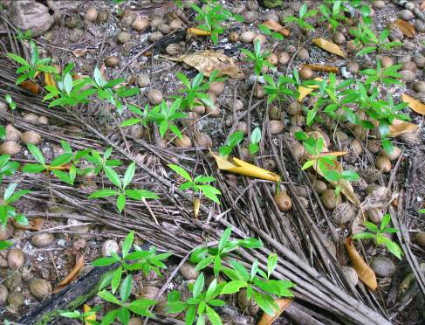
Full tree form | Germinating fruits;  Details of leaf, flower, & fruit
Native or Introduced: Native

Description: It is a shrub or tree that can reach up to 45 m tall with a trunk up to 50 cm in diameter. The large shiny leaves are arranged around the stem.
There is a head of white flowers which are fragrant. The fruit is the size of a small mango, with a point at the end, and green turning yellow when it ripens. The seed is thin and winged. The large shiny oval leaves, white flowers, and large fruits make this tree distinctive, together with the dense fence of seedlings that develop beneath the canopy of the parent tree.
Habitat: It is found along seashores, and in coastal forests, less often inland.

Human uses: Rich in alkaloids and used in traditional medicine. Its seeds are edible, and its flowers are fragrant and its wood is used for timber.

Significance: Good smaller tree, grows rapidly, and could provide shade for slower growing saplings.

Propagation: It can be propagated easily from seeds, and maybe cuttings. Saplings abound around the canopy perimeter of mature trees, forming a living fence, and smaller ones would probably transplant easily.

